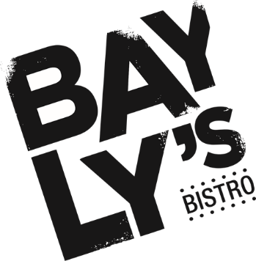
TRILOGY DAY MENU

ENTREE

Mushroom and gruyere arancini,
truffle mayo
12

Herb and parmesan polenta chips,
salsa verde, lemon
12

Freshly shucked Sydney rock oyster,
lemon, mignonette
4 each

Gently smoked king trout salad, confit heirloom tomato,
kipfler potato, green beans, rocket
20

Free range chicken and herb terrine,
sourdough, pickles, onion marmalade
16

MAIN

Pasture fed char grilled oyster blade,
kipfler potato, sweet and sour onions, pancetta
37

Whole baby Humpty Doo Barramundi,
pickled fennel, sauce vierge, lemon
36

Gently cooked free range chicken,
crispy polenta, ratatouille
35

Roman gnocchi,
broccolini, zucchini, roasted truss tomato
29

SIDES

Fries 8

Green beans, hazelnuts, lemon, pecorino 12

Iceberg lettuce, rocket, radish, vinaigrette 8

DESSERTS

Amaretto crème brulée
with hazelnut praline ice cream
$16

Summer pavlova,
citrus curd, chantilly, fruits
$16

Affogato
Choice of Bailey’s, Kahlua or Frangelico liqueur,
triple chocolate cookie
$14

Selection of ice cream and sorbet
(two scoops)
$12

TEA & COFFEE

Hot Chocolate $4

Coffee $4
Cappuccino, flat white, latte, long black,
macchiato, piccolo
Full cream milk and skim milk
Soy milk, Almond milk +0.5
Double shot +0.5

Espresso $3.5

Chai Latte $4

Tea $3.5
English breakfast, earl grey,
green tea, peppermint,
chai tea, chamomile
and lemongrass & ginger

